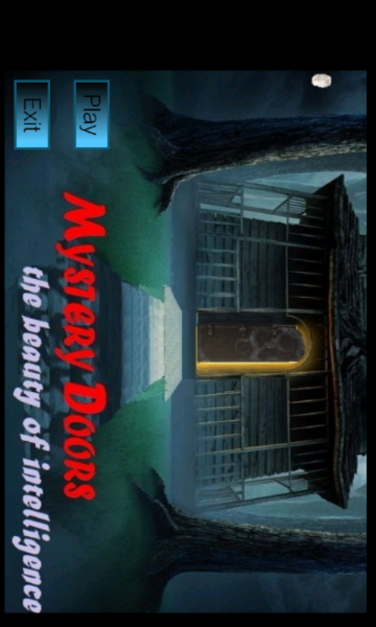

When the user clicks on the application icon, the Menu Page is displayed.

The Menu Page Consists of the Main Title, and two buttons, PLAY and EXIT.

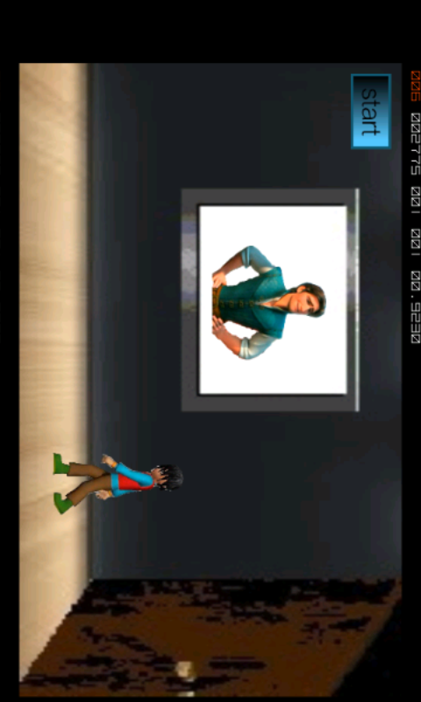

When the user clicks on the PLAY button, this introductory Page is opened where

the introduction of the game takes place.

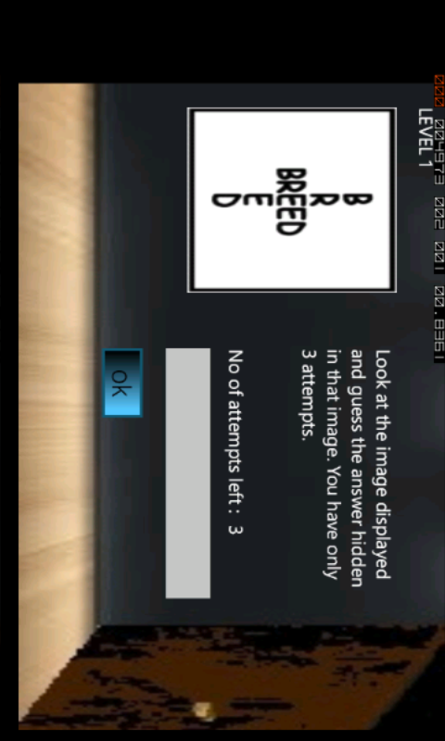

After the completion of the introduction the CONTINUE button is enabled.

When the user clicks on the CONTINUE button the first question of the first level

is displayed. When the user types the right answer, the next question is unlocked.

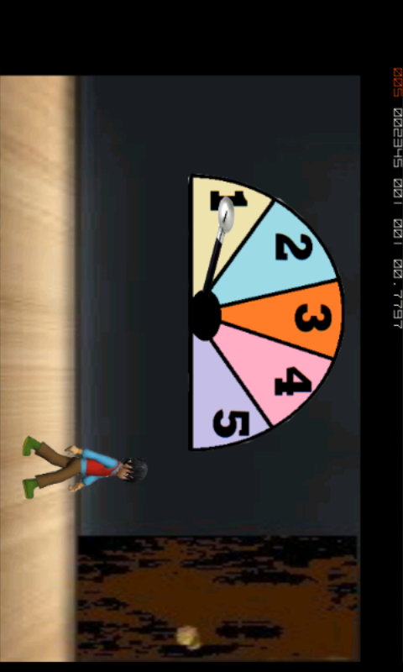

After all the 3 questions of level 1 is answered, this page is displayed to show the user

that he has completed the first level.

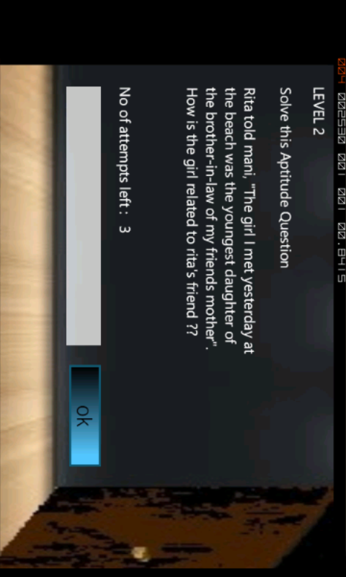

This is the sample of the question displayed to the user, the text field is provided

to write the correct answer. If the answer is wrong, the user is notified.

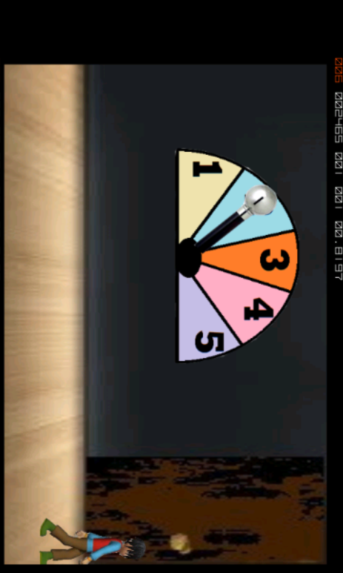

This is to show the user that he has completed 2nd level.

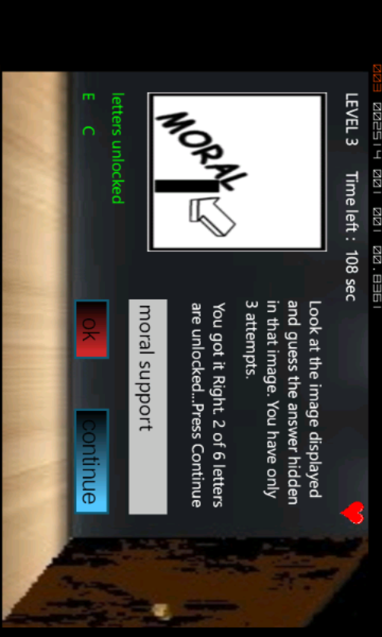

This is the screenshot of the 3rd level. Here we have introduced a time-constraint and a bonus life for the user.

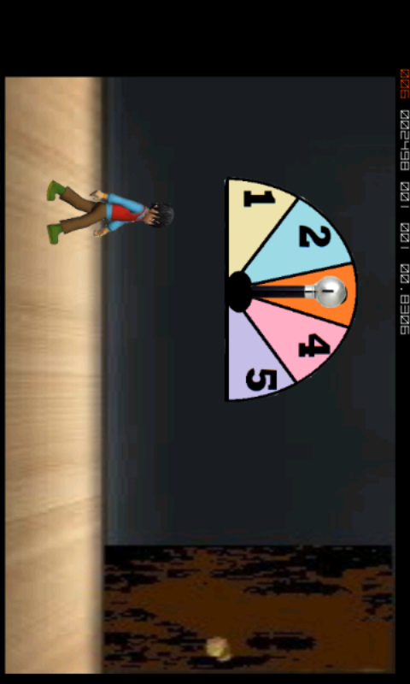

This screenshot to let the user know that he has completed the 3rd level.

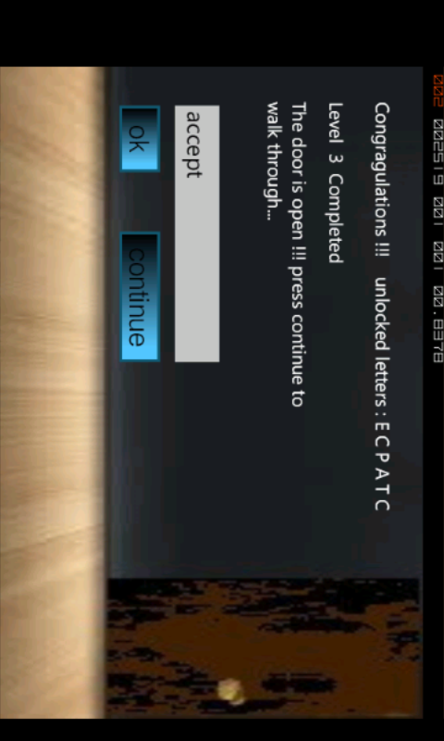

In the level 3, we have introduced the concept of the “password”. When the user answers 3 questions correctly, the jumbled password is unveiled, the user should then form this into the meaningful word.

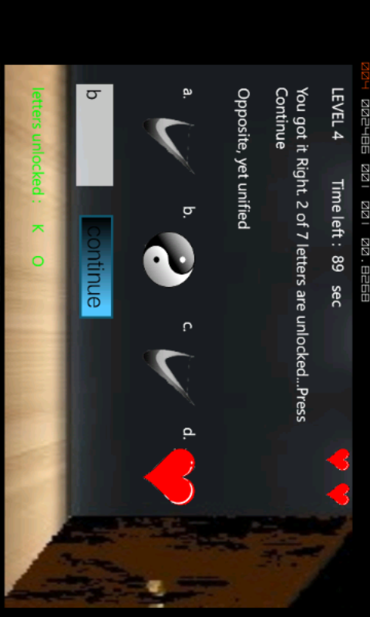

This is the 4th level of the game. The user is givena set of images and a related image. The user is supposed to give the right answer.

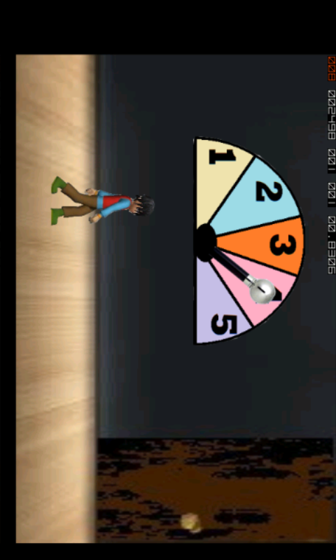

This is to let the user know tha he completed the 4th level

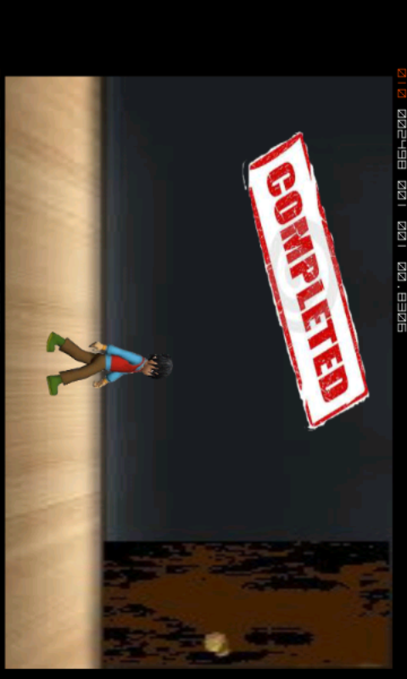

After the completion of all the levels, the user is notified.

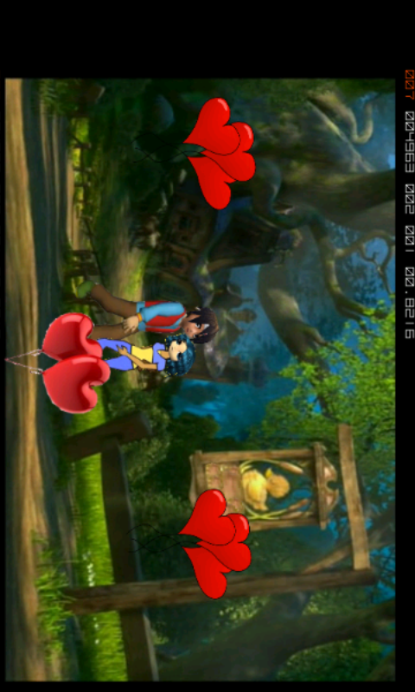

This is the last scene of the game, when the user unlocks all the doors he rescues the girl.

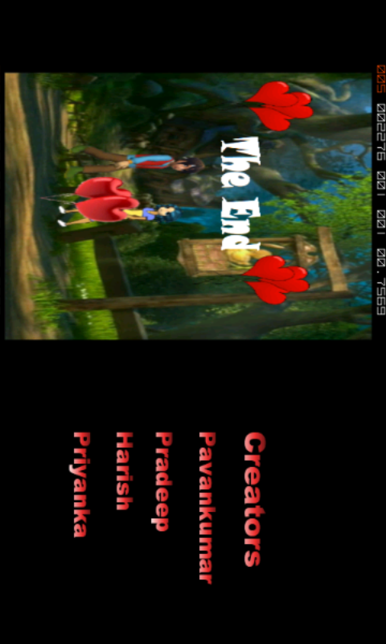

At the end of the game, the credits are displayed.

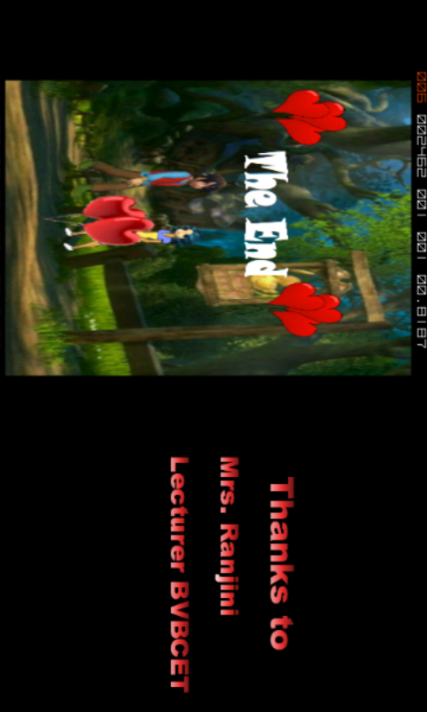

Further credits are displayed. This is the last scene of the game.